AMAZON SALES ANALYSIS
Project Overview-
This project focuses on analyzing Amazon sales data to extract meaningful business insights related to product performance, customer behavior, revenue trends, and discount patterns. The analysis is performed using structured data techniques and visualizations to support data-driven decision-making.
The dataset includes key attributes such as product category, product name, order details, sales amount, discounts, and yearly performance. Using Excel-based analysis and charts, the project identifies top-performing products, high-revenue categories, customer purchase frequency, and discount impact on sales.
Various analytical insights are generated through pivot tables, summary statistics, and visual dashboards to make the data easy to interpret. The project helps in understanding sales distribution across categories, identifying peak-performing periods, and evaluating customer ordering patterns.
Overall, this project demonstrates practical skills in data analysis, business intelligence, and visualization, making it useful for roles in data analytics, business analysis, and operations.
Objective and Purpose-
The objective of this project is to conduct an in-depth analysis of over 100,000 rows of Amazon sales data to uncover actionable insights into product performance, category-wise revenue, customer purchasing behavior, and the impact of discounts.
The purpose is to enable data-driven decision-making by identifying top-performing products, revenue-generating categories, sales trends, and customer patterns, while demonstrating proficiency in handling large-scale datasets, Excel-based analytics, and visual data representation techniques.
Problem Statement-
Amazon generates massive volumes of sales data across products, categories, and customer segments. However, raw data alone does not provide actionable insights, making it difficult for businesses to identify top-performing products, understand customer purchasing behavior, evaluate discount effectiveness, and make informed decisions. This project addresses the challenge of analyzing large-scale sales data (100,000+ rows) to extract meaningful insights and trends that can guide strategic business decisions.
Importance and Relevance –
Analyzing Amazon sales data is crucial for understanding product performance, customer behavior, and revenue patterns in a highly competitive e-commerce environment. Insights derived from large-scale datasets 100,000 rows help businesses optimize inventory, pricing, and promotional strategies, identify high-revenue categories, and improve customer targeting. This analysis is relevant for making data-driven decisions that enhance sales performance, operational efficiency, and strategic planning.
Tools and Technologies used-
1. Microsoft Excel & Python (pandas)
Excel, combined with Python’s pandas library, was used for initial data cleaning and preparation. Tasks such as removing duplicates, handling null values, and standardizing formats were performed to ensure the dataset was accurate and ready for analysis. This step laid the foundation for all subsequent insights by ensuring data consistency and reliability.
2. SQL
SQL was used to extract meaningful insights from the cleaned dataset. Complex queries involving filtering, grouping, and aggregations helped identify key trends such as high-performing products, category-wise revenue, and customer purchasing patterns. SQL made it efficient to handle large datasets and extract structured summaries for further analysis.
3. Python for Advanced Analysis
The SQL-processed data was loaded into Python for advanced analysis, including calculating contribution percentages, segmenting products into categories, and identifying performance patterns. Python’s data manipulation capabilities allowed deeper insights that go beyond basic aggregations, enabling detailed classification and business-level interpretation.
4. Matplotlib
Python’s Matplotlib library was used to visualize the insights effectively. Charts and graphs were created for each key metric, allowing trends, contributions, and category comparisons to be represented visually. This made the data more understandable and actionable for stakeholders.
5. Python Automation (openpyxl)
Using Python automation with openpyxl, each insight, along with its corresponding data and chart, was exported into separate Excel sheets. Every sheet represents a distinct insight, making the final output highly readable, structured, and presentation-ready. This automated workflow significantly reduced manual effort and ensured consistent formatting across all sheets.
Data Analysis using SQL-
Top 5 Products by Total Sales Amount -
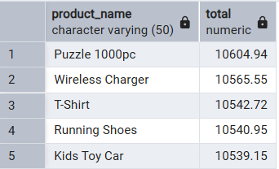
Category-wise Total Sales Amount Analysis-
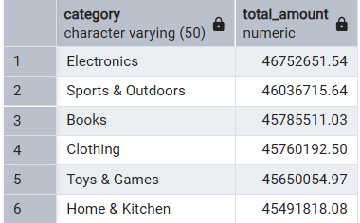
Top 5 Brands by Total Sales Amount-
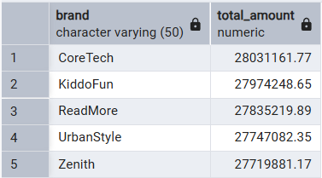
Top 5 Customers with More Than 2 Orders in 2024-
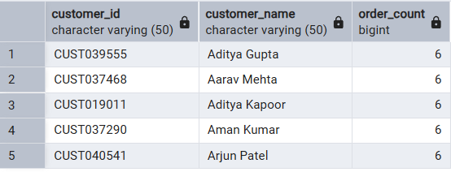
Customers with More Than 2 Orders in 2023-
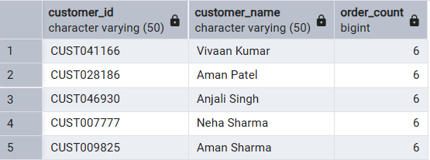
Top 5 Products by Total Sales in 2024-
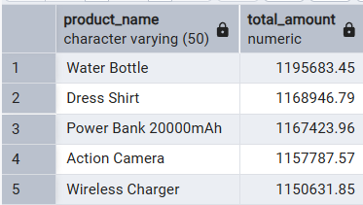
Top 5 Products by Total Sales in 2023-
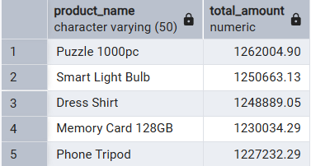
Product with Maximum Total Amount-
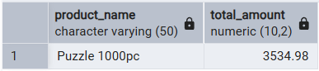
Product with Minimum Total Amount-
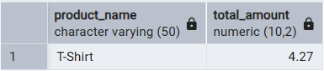
Category-wise Total Discount Analysis-
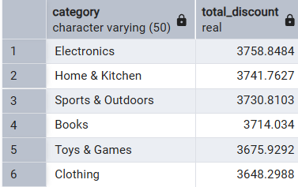
Category-wise Total Tax Collected-
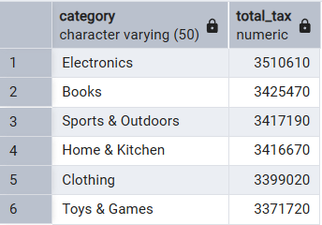
Top 5 Products by Shipping Cost-
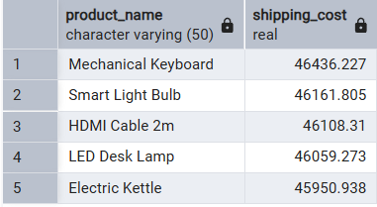
Total Sales by Payment Method-
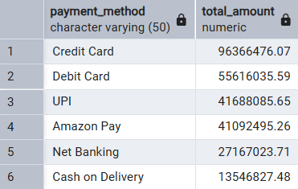
Total Sales Amount by Country-
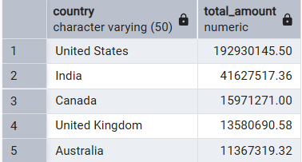
Order Count by Status-
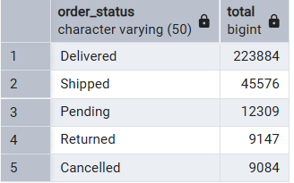
Python Automation using (openpyxl) –
Percentage Distribution of Sales by Product Category-
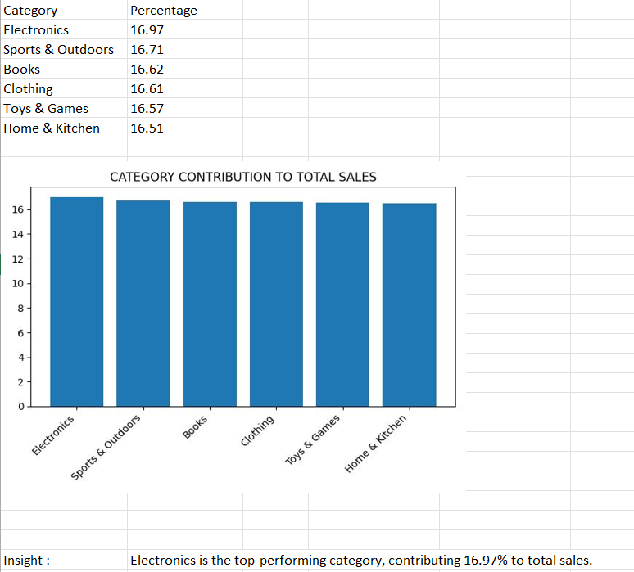
Sales Distribution by Country-
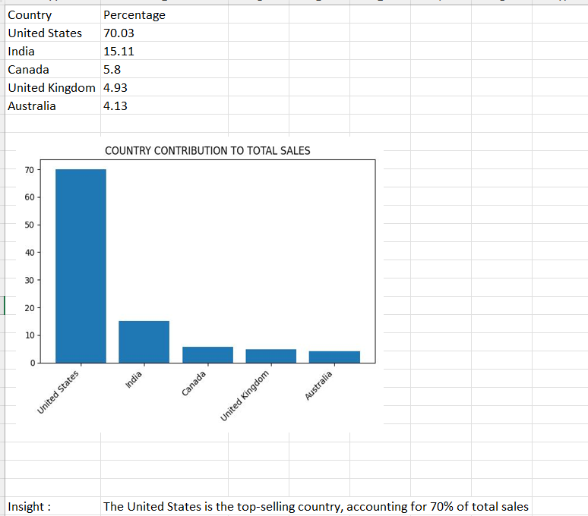
Highest Tax paid by categories-
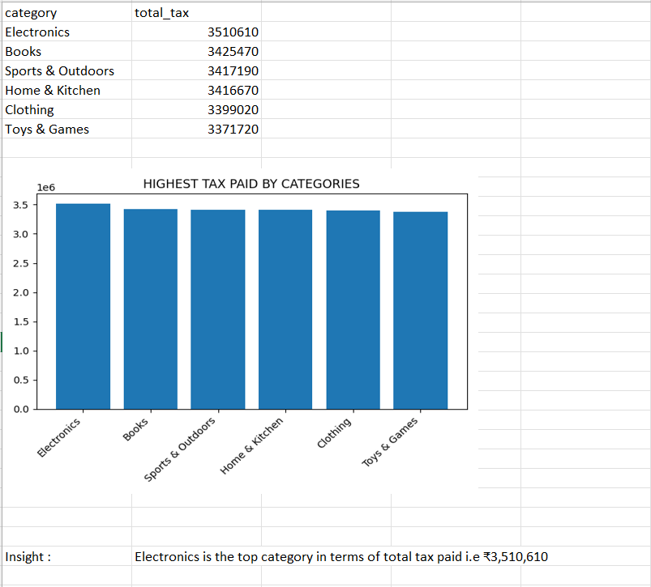
Maximum price of product –
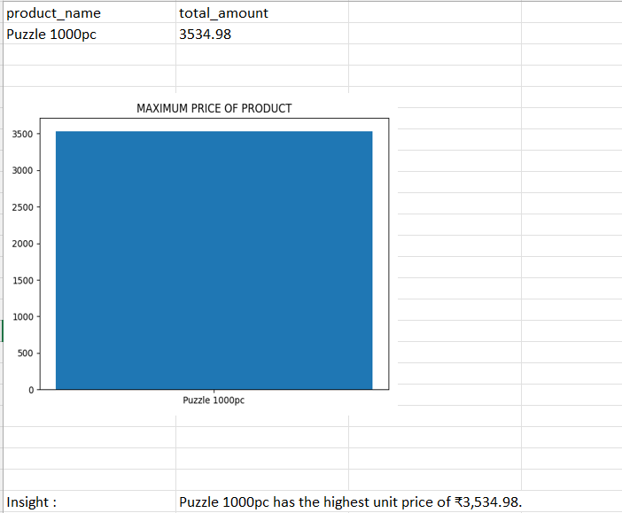

Most preferrable payment method by customers-
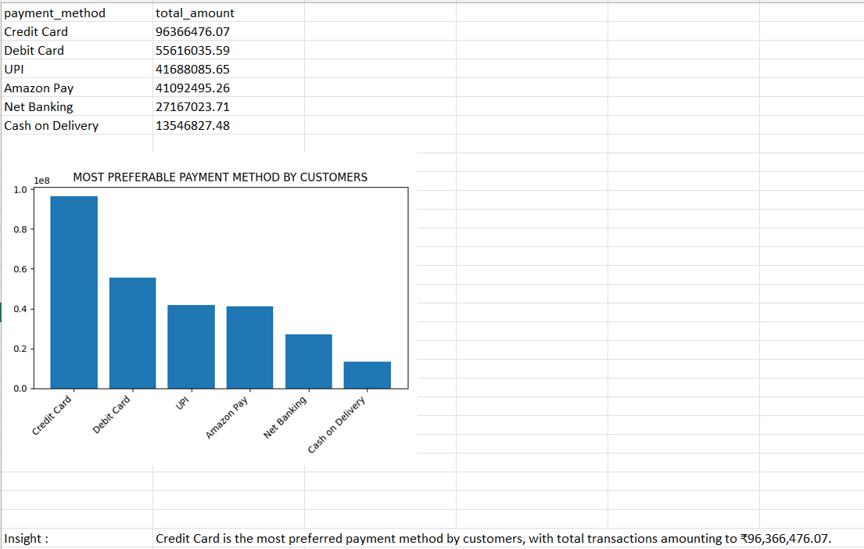
Order Status breakdown –
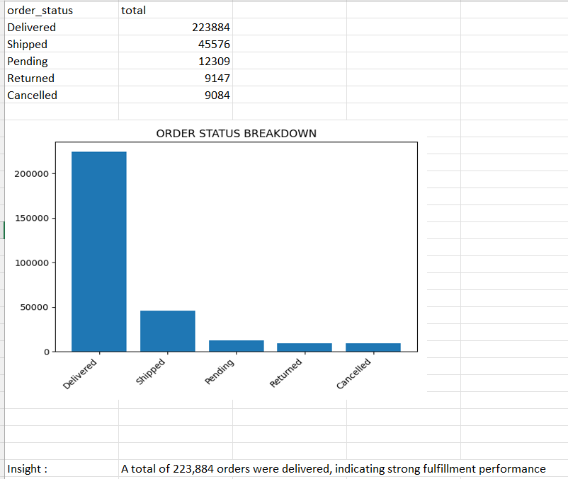
Order status percentage –
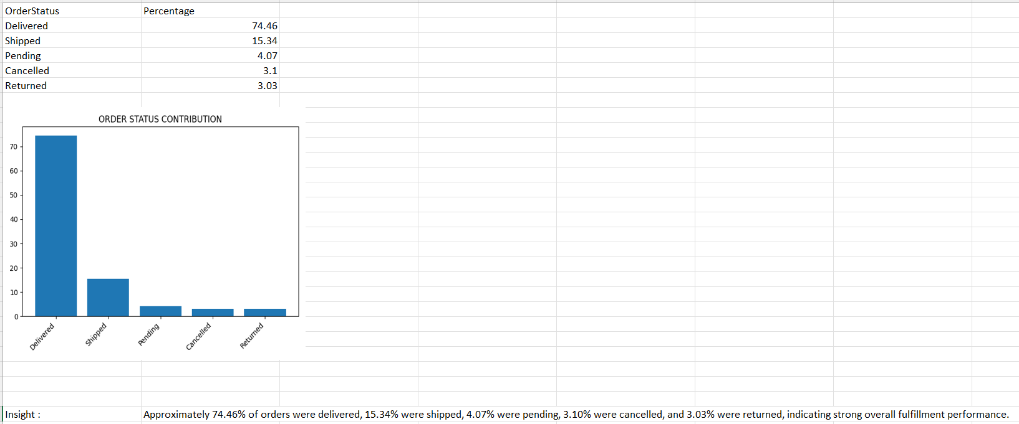

Top 5 brands –

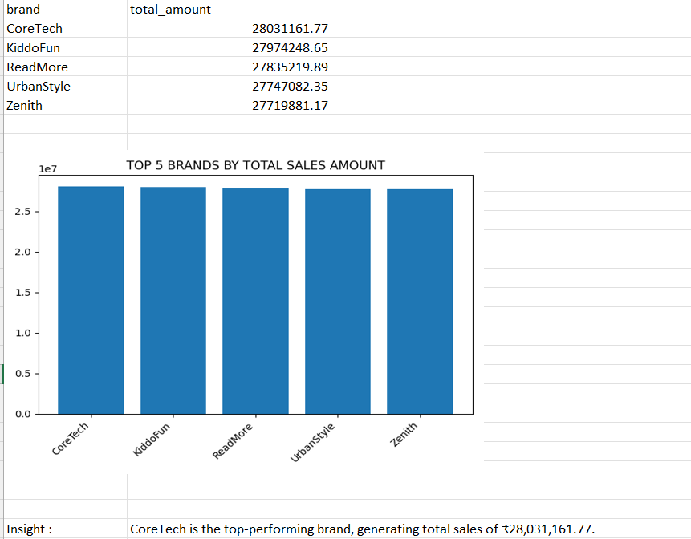
Top 5 products by total sales amount in 2023 –
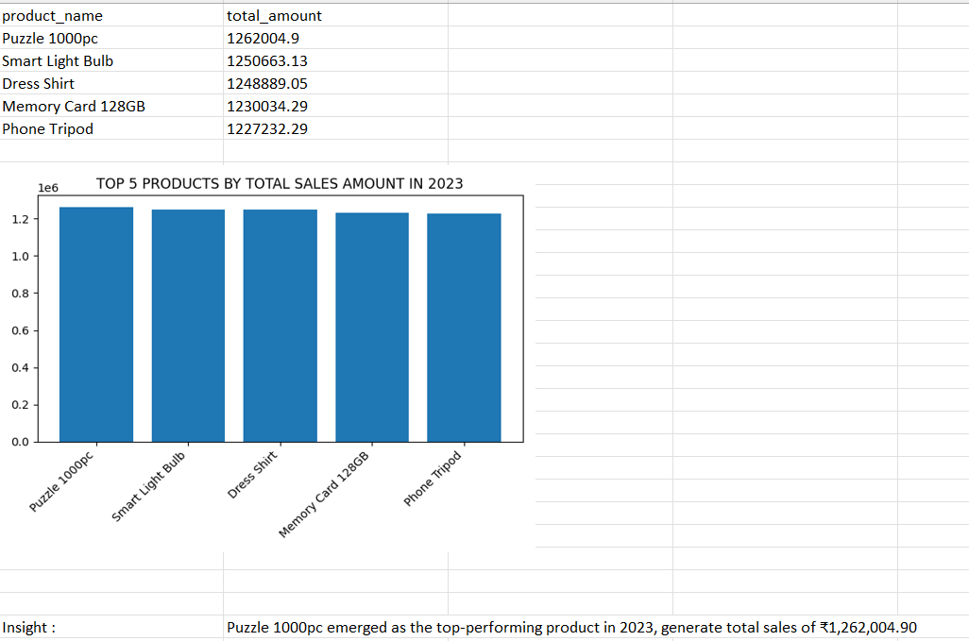
Top 5 products by total sales amount in 2024 –
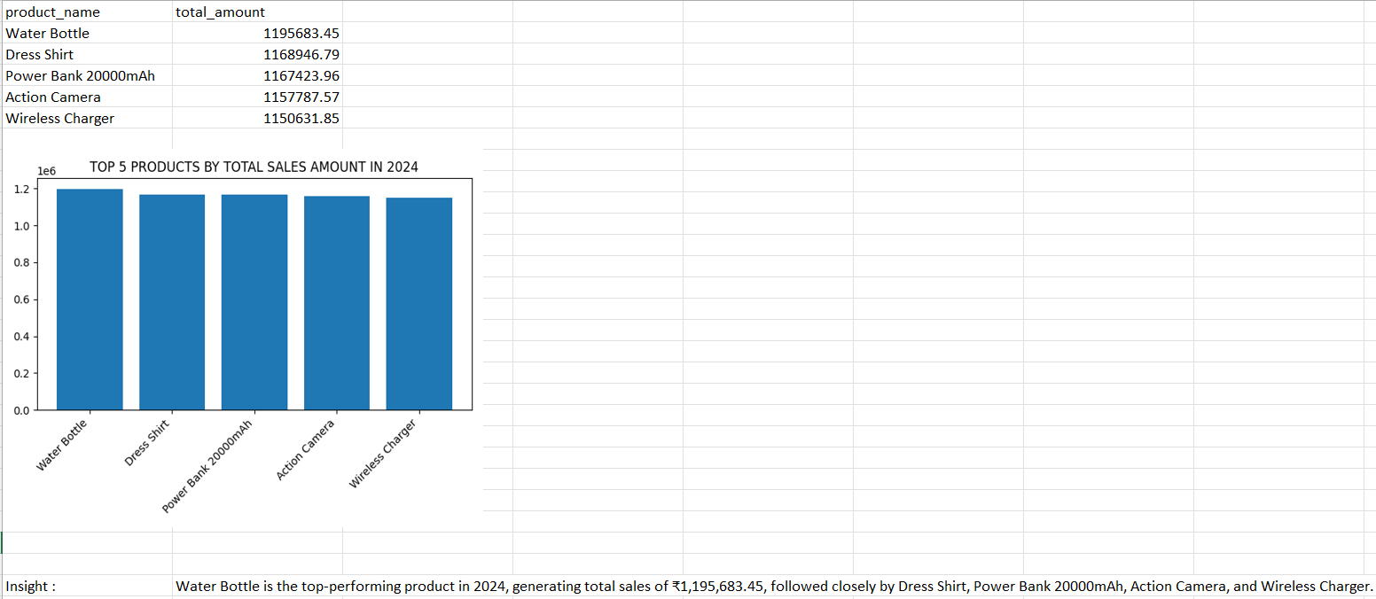
Total sales by category –
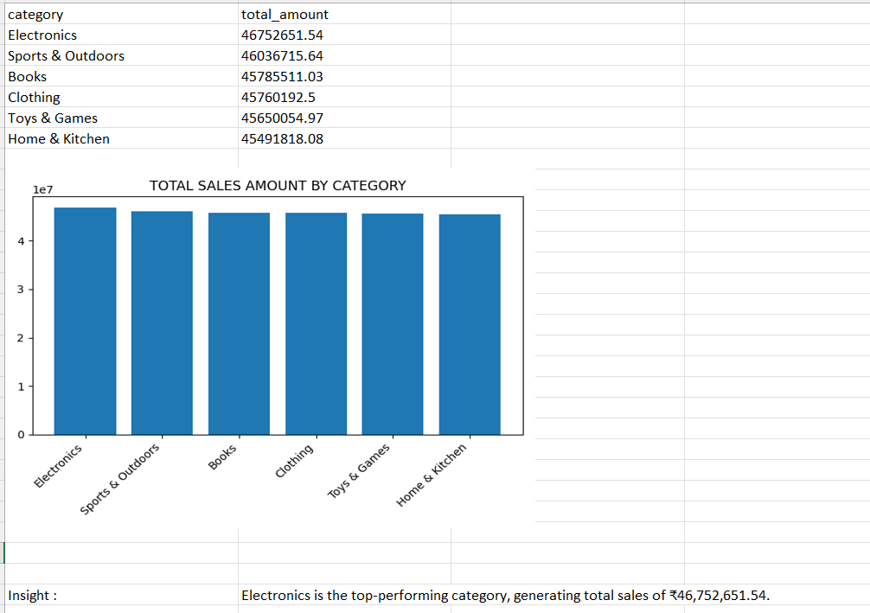
Total sales by country –
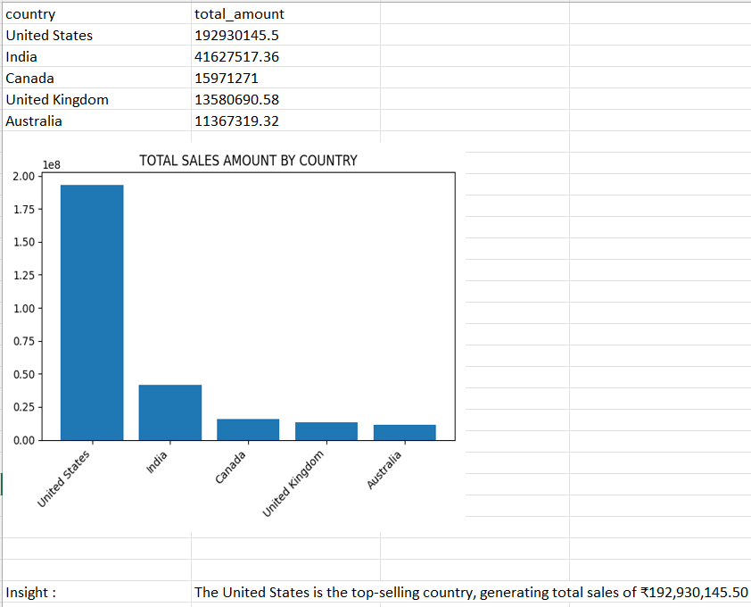

Dashboard in POWER BI –
This project involved the design and development of an interactive dashboard to analyze Amazon sales data and support data-driven decision-making. The primary objective of the dashboard was to transform raw sales data into meaningful insights by visualizing key performance indicators (KPIs) related to sales, products, customers, and geographic regions.
The interactive dashboard provides a comprehensive view of Amazon sales performance using multiple KPI cards, filters, and visualizations. The KPI cards display key metrics such as Total Sales, Total Quantity, Total Customers, Total Tax, and Total Discount, enabling quick performance assessment.
Interactive filters for Country, Year, and Payment Method allow users to dynamically refine the analysis, with all KPI cards and charts updating in real time. The dashboard includes column charts, bar charts, and line charts to compare category-wise and country-wise performance and to analyze sales trends over time.
Overall, the dashboard offers a clear, user-friendly, and interactive platform for monitoring sales performance and supporting data-driven decision-making.
